Create Accounting
in Oracle R12

DOCUMENT HISTORY
Version | Date | Comments | Author(s)
01 | 21/10/2016 | Initial version of Create accounting program in Oracle R12 | Sibraj Banerjee

Table of Contents
1.Create Accounting Program 3
2. Overview .............................................................................................................................3
3. Features ..............................................................................................................................3
4. Create Accounting Program parameters .3
5.Create Accounting in Payables 5
5. Steps to create accounting entries for an invoice, payment, or payment batch.......................5
6. Submitting the Create Accounting Program 5
7. Create Accounting in Receivables 6
8. Overview .............................................................................................................................6
9. Stepwise flow from transaction to journal entry in R12 ........................................................ 6
10. Oracle R12 Diagramatic Flow from Transaction to Journal Entry ……………………....................9

Create Accounting Program:
Overview:
Accounting transactions are originated as a result of normal business activities which are
recorded in different modules of oracle application; The Create Accounting program in Oracle
R12 processes eligible accounting events to create sub ledger journal entries. To create the sub
ledger journal entries, the Create Accounting program applies application accounting
definitions that are created in the Accounting Methods Builder (AMB).
Features:
- Validates and creates sub ledger journal entries
- Transfers the final journal entries in the current batch run to General Ledger and starts the General Ledger posting process(if instructed)
- Generates the Sub ledger Accounting Program Report, which documents the results of the Create Accounting program

Create Accounting program parameters:
Following are mandatory parameters for running the “Create Accounting” program.
- Ledger: If the profile option SLA: Enable Data Access Security in Sub ledgers is set to Yes, only those ledgers that are included in General Ledger Access Sets assigned to the responsibility appear in the list of values.
- End Date: Specifies the last date for the date range for which accounting entries are created.
- Mode: 2 modes are available:
Draft:
- Will create Journal Entries, which are NOT final, which means they are NOT ready to be transferred to GL
- You can run create accounting on this transaction again and again, which will delete the old journal entries and create new ones.
- You can't transfer these journal entries to GL

Final:
- This will create journal entries, which can be transferred to GL
- Once it is finally accounted you can NOT run create accounting on the particular
transaction (specifically on that event).
- You can transfer them to GL using Transfer Journal Entries to GL program.

- Errors Only: Limits the creation of accounting to those events for which accounting has previously failed.
If Yes is selected, the Create Accounting program processes all events with a status of Error.
If No is selected, the Create Accounting program processes all events with a status of Error or Normal.
- Transfer to General Ledger :
Yes:
- It will create journal entries in suitable mode which can be transferred to GL.
- You can see the accounting in XLA_AE_HEADERS and XLA_AE_LINES.
- Once it is finally accounted you can NOT run create accounting on the particular transaction (specifically on that event).
No:
- This will create journal entries, which cannot be transferred to GL
- Once it is finally accounted you can NOT run create accounting on the particular transaction (specifically on that event).
- You can transfer them to GL using Transfer Journal Entries to GL program separately.
.
- Post in General Ledger
- This will create journal entries in Final Mode, Transfer them to GL and Post them.
- Once it is finally accounted you can NOT run create accounting on the particular transaction (specifically on that event).
- It will transfer the journal entries to GL using Journal Import and you can find the data in GL_JE_HEADERS and GL_JE_LINES
- It will post to gl_balances also (GL_JE_HEADERS.status is 'P').

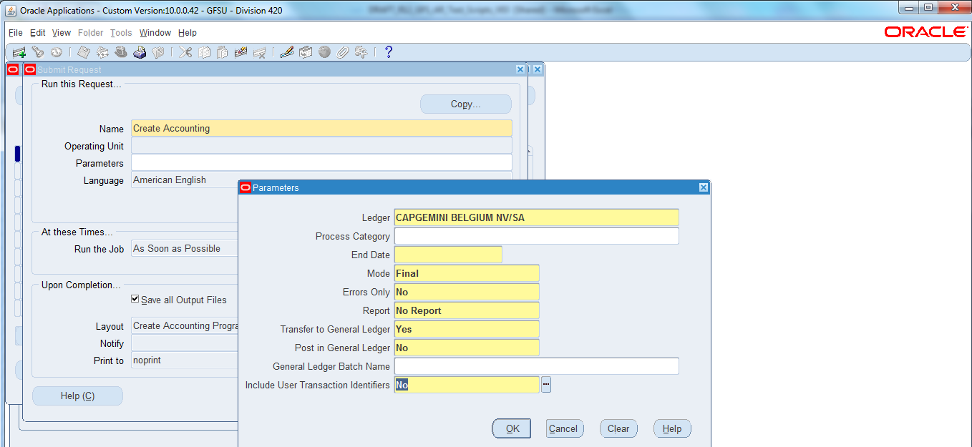

Create Accounting in Payables

The processes for transferring accounting created in Payables to the GL (including the AX process) is replaced with Create Accounting in R12 which creates and validates sub ledger entries in SLA, transfers entries in the current batch to GL, starts the GL posting process, and generates a sub ledger accounting report

Creating Accounting Entries from Transaction Windows

From a transaction window, you can create accounting entries for a selected invoice, payment, invoice batch, or payment batch. For a single invoice or payment, the accounting completes online. For batches, the accounting process is submitted as a request, and you can view its completion status in the Requests window.

Steps to create accounting entries for an invoice, payment, or payment batch:

Query and select the invoice, payment, or payment batch in the Invoices, Payments, or Payment Batches window.

Choose the Actions button.

The actions window for the transaction opens. Choose the Create Accounting check box.

Choose one of the following options:

Draft

Final

Final and Post

Choose OK.

Submitting the Create Accounting Program

Create Accounting program can be run manually to create accounting entries for multiple transactions. You can also use this program to generate detailed error reports if you could not successfully create accounting entries from the transaction windows.

Submit the Create Accounting program in Draft mode, if you want to view the accounting results before you create the final accounting, or Final mode.

Create Accounting in Receivables
Overview:
In R12 Receivables, the accounting needs to go through the Sub ledger Accounting module. This module will take the default accounting derived from the module setups and then apply any override rules. The module will then generate the journal lines and journal entries to send to the General Ledger.
Stepwise flow from transaction to journal entry in R12
Following is the sequence of steps of flow from transaction to journal entry in R12:
1) Enter the transaction in Receivables.
2) After the transaction is entered Oracle will need to find the operating unit associated with your transaction. The operating unit is linked to the responsibility by system profile settings.
3) Once Oracle finds the operating unit, it can find the ledger. The ledger is associated with operating unit via an organizational attribute.
4) Once it has determined the operating unit, Oracle will find the accounting setups associated with that module’s operating unit.
5) These setups are used to create the transaction’s distributions. Along with the GL accounts, Oracle will record the ledger to the distribution.
6) The distribution contains the default GL accounts used in the Subledger Accounting rules.
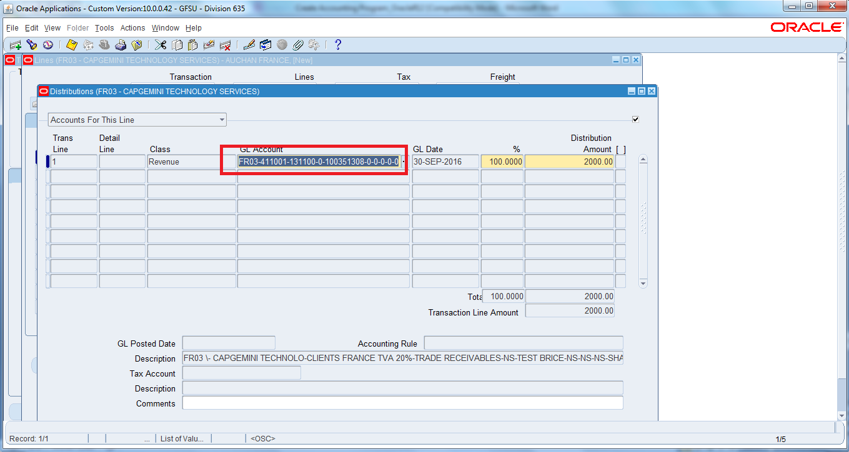
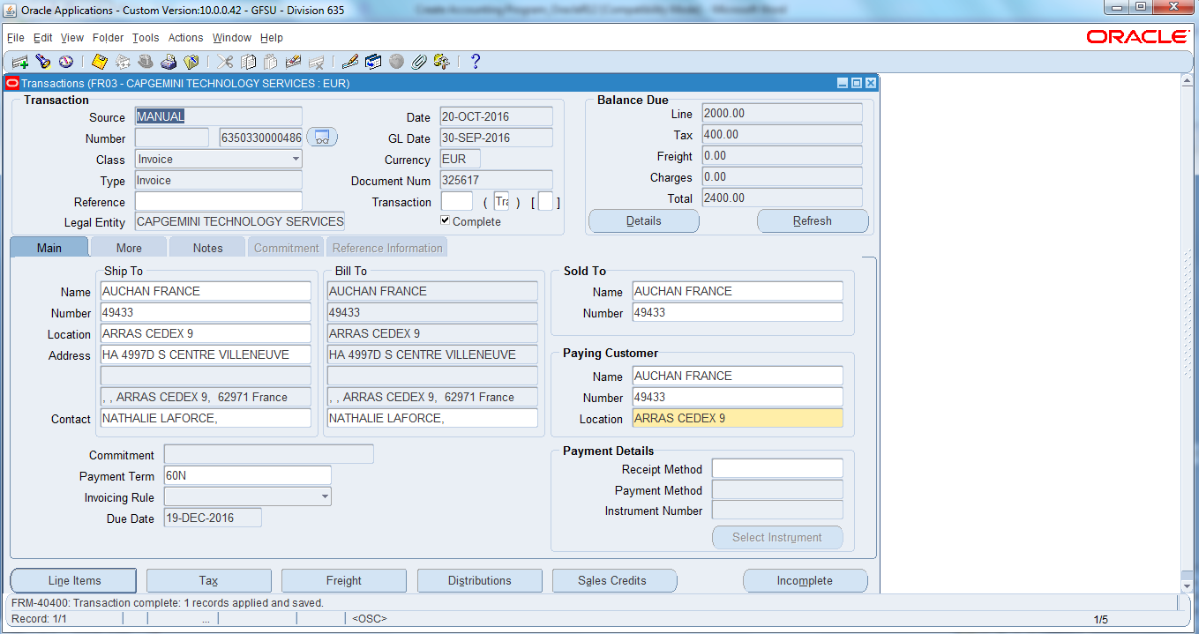
- After the transaction distribution is created, you can run the “Create Accounting” program. When you run the create accounting program, Oracle will find the Sub ledger Accounting Method for the transaction’s ledger. The Subledger Accounting Method lists the Application Accounting Definition for each module that creates accounting.
Steps:
- Go to Tools → Create Accounting menu option on Transactions window.
- In Create Accounting pop-up select any of the following options and click OK Button:
- Create Final Accounting Post to GL
- Create Final Accounting
- Create Draft Accounting
Message is displayed “Accounting created for this transaction”.
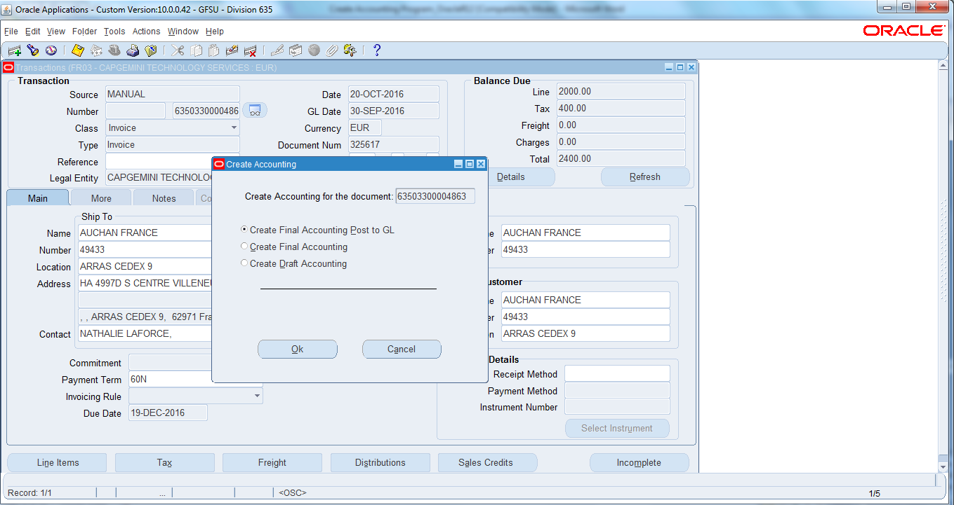
- Go to Tools → View Accounting menu option on Transactions window.
- Sub ledger Journal Entry Lines window opens with debit, credit breakup being displayed for Accounting Class.
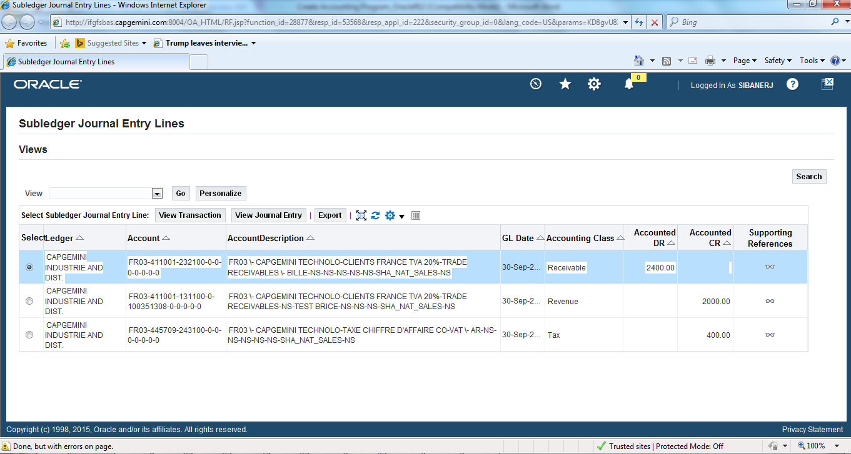
8) After the Sub ledger Accounting Method is found, the system uses the transaction’s module to find the Application Accounting Definition for the module. The Application Accounting Definition contains a list of all the transaction event classes and types with the associated Journal Lines Definition.
9) Once the Application Accounting Definition is found, the system will use the transaction to determine the event class and type.
10) Once the event class and type are found, the system will find the associated Journal Lines Definition. The Journal Lines Definition contains a list of all the different journal lines that can be created for that event class. These journal lines sometimes can be mapped directly to fields in the transaction’s distributions. Two examples of transaction distribution field’s mapping to Journal Line Types are the Line Type field in Payables Invoice Distributions and the Accounting Type field in the Inventory Material Distributions (please see screen shots at the end of this post).
11) Using the Journal Line Definition, Oracle will create a Journal Line for each Journal Line Type.
12) The Journal Line Type will look at the Account Derivation Rules. The Account Derivation Rules derive the GL accounts for either all segments in the Accounting Flexfield or map a GL account for a single segment. Oracle determines the GL accounts based on mapping sets and/or conditions in the Account Derivation Rules. You can use information from the transaction or the transaction distribution set in your Mapping Sets and your Account Derivation Rules.
13) After all the GL accounts have been determined, Oracle will then create the journal lines and then create the journal entries to interface to the General Ledger.
Oracle R12 Diagramatic Flow from Transaction to Journal Entry

